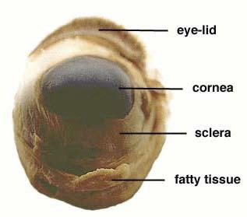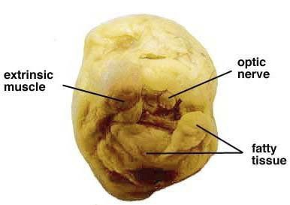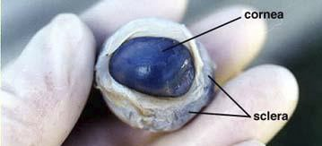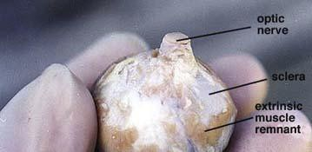

SHEEP EYE DISSECTION PROCEDURES

The anatomy of the human eye can be better shown and understood by the actual dissection of an eye. One eye of choice for dissection, that closely resembles the human eye, is that of the sheep. Differences between the two eye types will be mentioned as the dissection is completed. Begin the dissection by gathering the equipment   
and supplies listed here.

Materials Needed: (sheep eye, dissecting pan, safety goggles, non-latex gloves, scissors, scalpel, probe,

forceps, paper towels and a notebook and pencil for recording information about the eye as it is dissected.)

Step 1: Wash the sheep eye in running water to remove the preservative fluid. Dry the eye with paper

toweling. Examine the front of the eye and locate the eye-lid, cornea, sclera (white of the eye) and fatty tissue. Examine the back of the eye and find extrinsic muscle bundles, fatty tissue and the optic nerve. The four   
extrinsic muscles (humans have six) move the sheep eye while the fatty tissue cushions the eye. If the optic nerve is not visible use the probe to move the fatty tissue around until the nerve is exposed. Take the notes you need to record what you have observed so far.

Step 2: Use your scissors to cut away the eye-lid (if necessary), muscle and fatty tissue from both the front   
and rear surfaces of the eye. Be careful not to remove the optic nerve. Cut along the surface of the sclera until   
all the tissue is removed and your specimen looks similar to the photographs you see here. The sclera is very   
tough so you do not need to worry about cutting into this layer of the eye. When you have finished removing   
the tissue surrounding the eye identify the sclera, cornea, optic nerve, and the remaining external muscle   
parts. The cloudy nature of the cornea is caused by the non-living tissue. It is transparent in the living state.

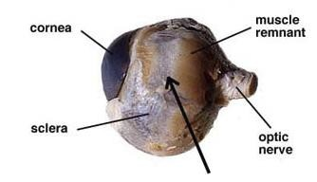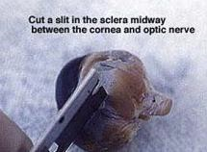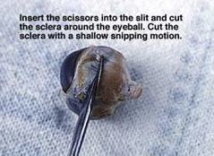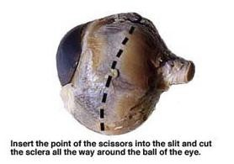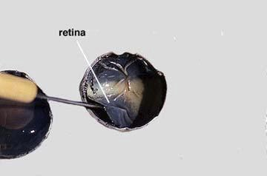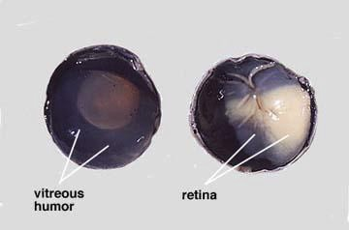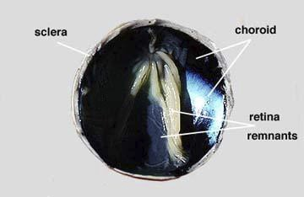

Step 3: Place your eye specimen in the dissection pan. Turn the specimen so the cornea is on the left and the   
optic nerve is on your right. Select a place to make an incision of the sclera midway between the cornea and   
optic nerve. Use the point of a very sharp razor blade to make a small cut through the sclera. Fluid should   
ooze out of the eyeball when you have cut deeply enough. You will be reminded of how tough the sclera is   
when you make this cut.

Step 4: Insert the point of the scissors into the slit made by the razor blade and cut the sclera with a shallow snipping motion. Turn the eye as you continue the cutting action. Cut the sclera all the way around the ball of the eye. You will need to support the eye in the palm of your hand while you complete this step of the   
dissection. Do not be surprised if some fluid from the eye oozes from the slit as you make this cut. Take the notes you need to record what you have observed so far.

Step 5: Arrange the two hemispheres of the eye as you see in the left photograph. Observe the semi-fluid

vitreous humor that fills the central cavity of the eye. It is transparent in the living eye but might be cloudy in the preserved specimen. The vitreous humor along with the aqueous humor (found behind the cornea) helps to maintain the shape of the eye. The retina lines the posterior (back) side of the eye and extends forward to   
the ciliary body (beneath the iris, used to make aqueous humor). Use your probe to lift and pull the retina back from the underlying choroid layer (found in-between the sclera and the retina, used to nourish the back of the eye). See the photograph on the right side above. Notice that the retina is only firmly attached to the choroid at one place. This region is the optic disc or blind spot. Here the nerve fibers leave the retina and form the optic nerve which is directly behind the blind spot.

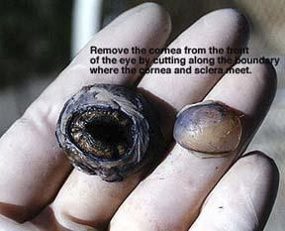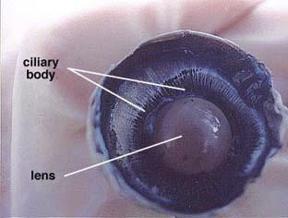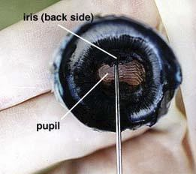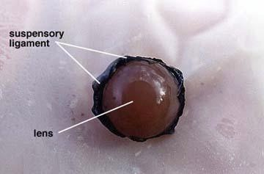

Step 6: Use your forceps to peel the retina away from the underlying choroid coat. The retina should remain attached at the blind spot. The choroid coat is dark and relatively thin. Use your forceps or probe to gently separate the choroid from the outer sclera. Verify that the eye has three distinct layers, the retina, choroid and sclera. See left photograph above. The choroid contains an extensive network of blood vessels that bring   
nourishment and oxygen to itself and the other two layers. The dark color, caused by pigments, absorbs light so that it is not reflected around inside of the eye. The tapetum lucidum, which is not found in the human eye, functions to reflect light onto the retina. It especially helps animals with night vision since it can reflect light even at very low intensities. It is shiny, glittering with a bluish color.

Step 7: Use your forceps and probe to remove the vitreous humor from the anterior (front) hemisphere of the eye. See right photograph above. This will take some time and effort as the semi-fluid material separates easily. It helps to turn the hemisphere on edge and to use a scrapping motion to remove the fluid. Try not to disturb the lens that is just below the vitreous humor.

Step 8: Removal of the vitreous humor reveals the lens, ciliary body and suspensory ligaments. In the

normal condition the lens is transparent except, when as a condition of aging, the lens turns cloudy. The

cloudy condition, called cataract, prevents or reduces the amount of light reaching the retina. Cataract can be treated by removing the lens and replacing it with a stiff artificial one. The normal lens is convex shaped and somewhat elastic. It is held in place by the suspensory ligaments that in turn join with the smooth muscle   
containing ciliary body. When the smooth muscle fibers contract the resulting force flattens the lens and the degree of bending of the light rays is reduced. Relaxation of the smooth muscle results in a thickening of the lens and a greater bending of the rays of light.

Step 9: Remove the lens by pulling it free from its attachments. Note the shape of the lens, its stiffness and opaqueness. Suspensory ligaments may also be visible along the edge of the lens.

Step 10: When the lens is removed, an opening, allowing light to enter the eye is seen. This opening, the

pupil is located in the center of the iris. Two muscle layers of the iris regulate the size of the pupil. One layer   
increases the pupil size with decreasing light intensity and the other layer reduces pupil size with increasing   
light intensity. Note the oblong shape of the sheep pupil, in humans the pupil is circular. The back side of the   
iris can be seen just above the pointer in the photograph. Part of the iris is being lifted by the pointer but the   
iris continues all the way around the pupil opening. A second cavity or space is present between the iris and   
the cornea. This space is filled with a second semi-liquid fluid, the aqueous humor. This fluid, like the vitreous   
humor helps to maintain the shape of the eye. Glaucoma is a condition where the fluid pressure becomes too   
high causing eye damage.

Step 11: Remove the cornea from the front eye hemisphere. Use a scalpel to   
puncture a small slit at the boundary between the cornea and sclera. Then insert   
the scissors into the slip and cut all the way around the cornea to remove it.   
Notice the thickness of the cornea. How does it compare to the thickness of the   
sclera? Carefully observe the front side of the iris and pupil. Which structure of   
the eye would be just behind the pupil opening? _________________________

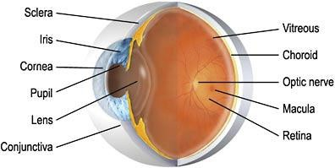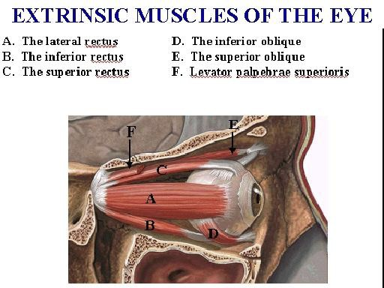

Step 12: Place all of your eye structures in a zip-lock bag. Wipe your dissection tray with an antibacterial cloth and put away all dissecting tools. Clean your lab area with another antibacterial cloth and work on laboratory questions. Wash your hands. ☺

Observe the eye model. Examine the external muscles (FYI)

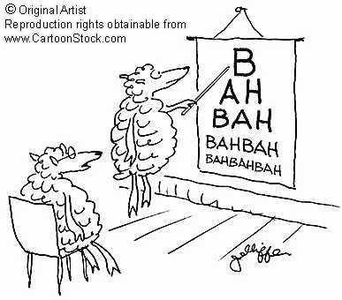

Sheep Eye Dissection Lab Sheet Name Per.

Follow instruction sheet for procedures. Date ________________

⬆ You and your partner will sign off (initial) on the chart as you find the structures. ⬆ You should be able to explain their functions, if asked by teacher.

1. Write three observations you made when you examined the surface of the eye:

⬆ ______________________________

⬆ ______________________________   
⬆ ______________________________

Part 2: External Anatomy

Identify: Place your initials here ☺

|  |  |
| --- | --- |
| ⬆ cornea |  |
| ⬆ sclera |  |
| ⬆ optic nerve |  |
| ⬆ external eye muscle |  |
| ⬆ fatty tissue |  |

Questions:

|  |
| --- |
| 1. Why don’t you have to worry about cutting into the sclera when you are removing the extrinsic muscles and  fatty tissue? |
| 2. How does the fat tissue look different from the muscle tissue? |
| 3. What is the choroid’s function? |
| 4. Why is the cornea so cloudy? |
| 5. What is the tapetum lucidum? Do human have this structure? Why or why not- explain. |

Part 3: Internal Posterior Anatomy

Identify: Initials

|  |  |
| --- | --- |
| ⬆ vitreous humor |  |
| ⬆ retina |  |
| ⬆ blind spot |  |
| ⬆ choroid |  |
| ⬆ peel layers of retina & choroid |  |

Questions:

|  |
| --- |
| 5. What is “posterior”? |
| 6. Besides cutting into it, how did you find out that the sclera is so tough? |
| 7. What was the consistency of the vitreous humor? How could you describe it? |

Part 4: Internal Anterior Anatomy

Identify: initials here ☺

|  |  |
| --- | --- |
| ⬆ ciliary body (muscle) | ⬆ |
| ⬆ lens | ⬆ |
| ⬆ suspensory ligament | ⬆ |
| ⬆ iris | ⬆ |
| ⬆ pupil | ⬆ |
| ⬆ aqueous humor | ⬆ |

Questions:

|  |
| --- |
| 8. What is the “anterior”? |
| 9. How do cilliary bodies (muscles) help you see? |
| 10. What is a cataract? |
| 11. Which structure of the eye would be just behind the pupil opening? |
| 12. What is “glaucoma”? |

Part 5: Cornea & Lens Questions:

|  |
| --- |
| 13. How does the thickness of the cornea compare to the thickness of the sclera? |
| 14. What shape is the sheep’s pupil? How does it compare to the shape of the human pupil? |
| 15. What color is your sheep’s iris (not the cornea)? |
| 16. Describe the texture of the lens. |

Part 6. Match the following parts of the eye to their function: (ciliary body, pupil, sclera, iris, retina, lens, & tapetum lucidum)

____________________ Contains the photoreceptors for vision. ____________________ The colored portion of the eye.

____________________ This structure changes shape to focus light on the retina.

____________________ The opening in the iris through which light passes.

____________________ The iridescent portion of the choroid layer in nocturnal animals. ____________________ Consists of muscles, which control and shape the lens.   
____________________ The white of the eye.

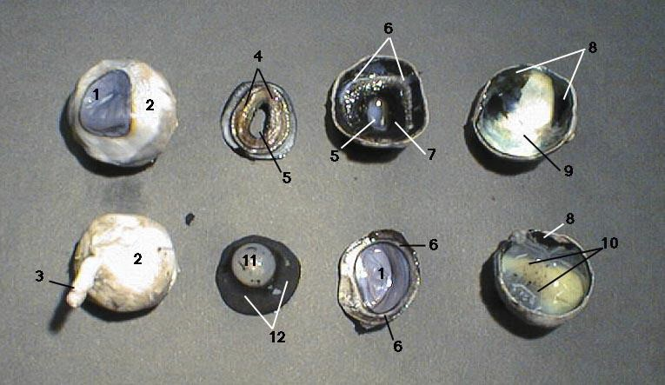

4. Use the pictures below to name the parts of the eye:

1. ________________________________________

2. ________________________________________

3. ________________________________________

4. ________________________________________

5. ________________________________________

6. ________________________________________

7. ________________________________________

8. ________________________________________

9. ________________________________________

10. ________________________________________

11. ________________________________________

12. ________________________________________