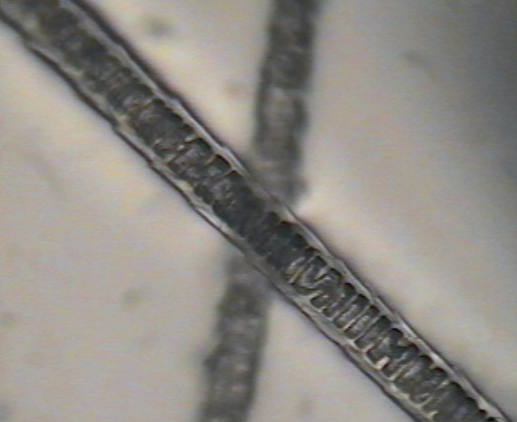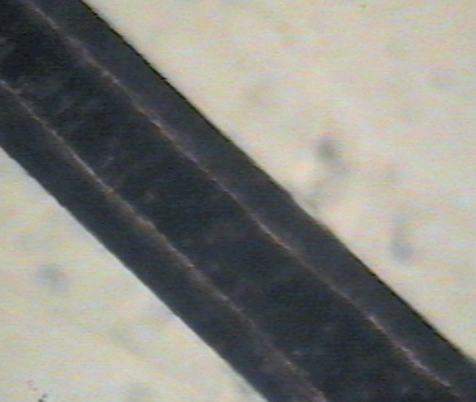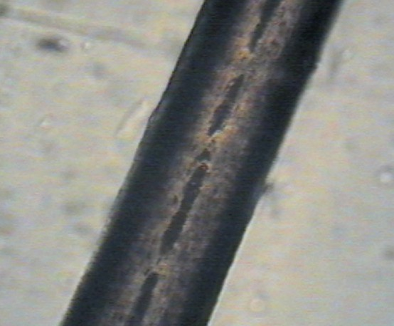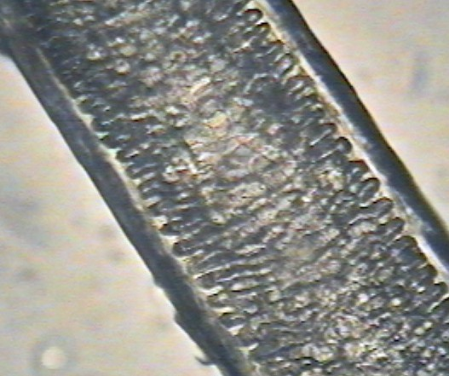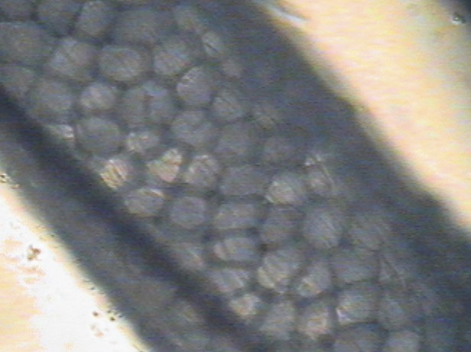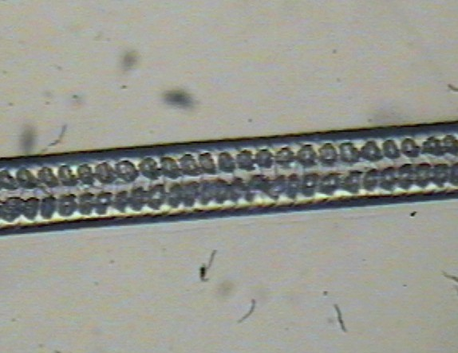

Hair Challenge

Work with a partner to identify the hairs shown below.

T. Trimpe 2007 <http://sciencespot.net/>

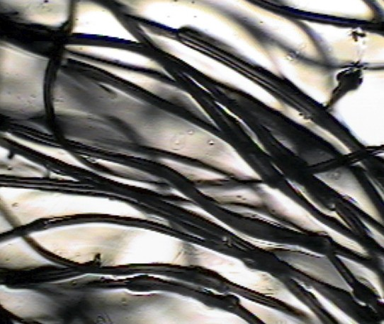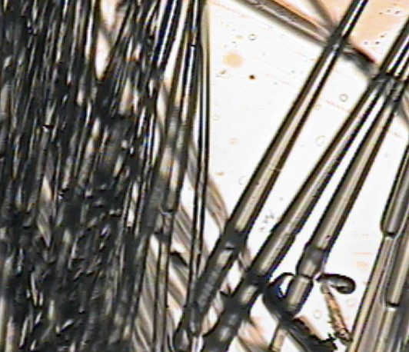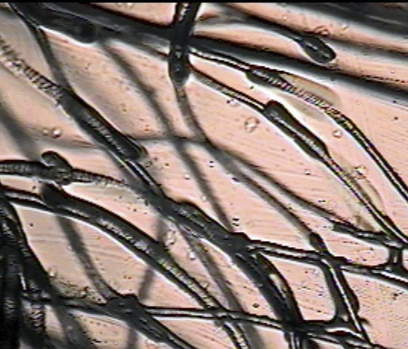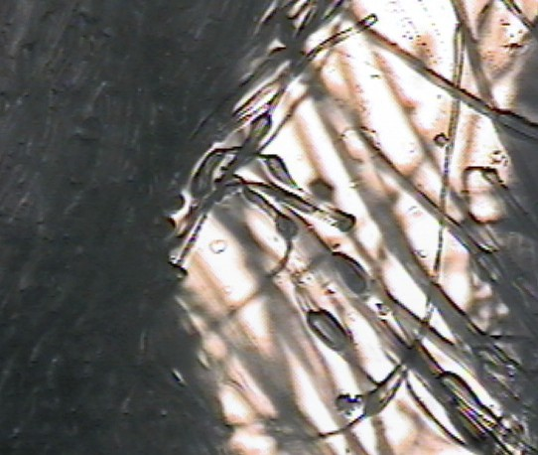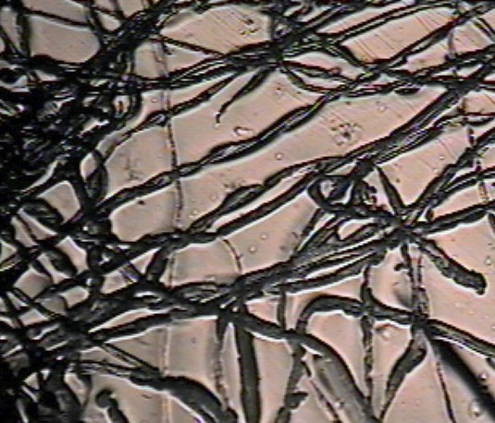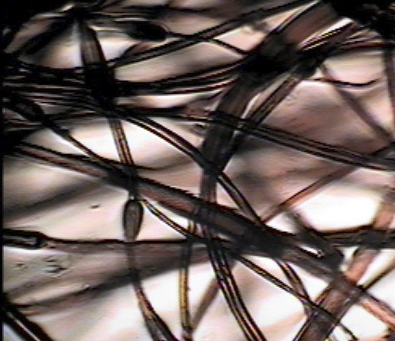

Fiber Challenge

Work with a partner to identify the fibers shown below.

T. Trimpe 2007 <http://sciencespot.net/>



Student Answer Sheets

Hair & Fiber Challenge

Names ____________________________ A - ___________________ Guesses

B - ___________________ Free

C - ___________________ Free

D - ___________________ Free E - ___________________

Hair & Fiber Challenge

Names ____________________________ A - ___________________ Guesses

B - ___________________ Free

C - ___________________ Free

D - ___________________ Free E - ___________________

F - ___________________   
G - ___________________   
H - ___________________   
I - ___________________   
J - ___________________   
K - ___________________   
L - ___________________

Hair & Fiber Challenge

95

90

85

80

75

70

65

60

F - ___________________   
G - ___________________   
H - ___________________   
I - ___________________   
J - ___________________   
K - ___________________   
L - ___________________

Hair & Fiber Challenge

95

90

85

80

75

70

65

60

Names ____________________________ A - ___________________ Guesses B - ___________________

Names ____________________________ A - ___________________ Guesses B - ___________________

C - ___________________   
D - ___________________   
E - ___________________   
F - ___________________   
G - ___________________   
H - ___________________   
I - ___________________   
J - ___________________   
K - ___________________   
L - ___________________

Free

Free

Free

95

90

85

80

75

70

65

60

T. Trimpe 2007

C - ___________________   
D - ___________________   
E - ___________________   
F - ___________________   
G - ___________________   
H - ___________________   
I - ___________________   
J - ___________________   
K - ___________________   
L - ___________________

<http://sciencespot.net/>

Free

Free

Free

95

90

85

80

75

70

65

60