**Trends Periodic Table**

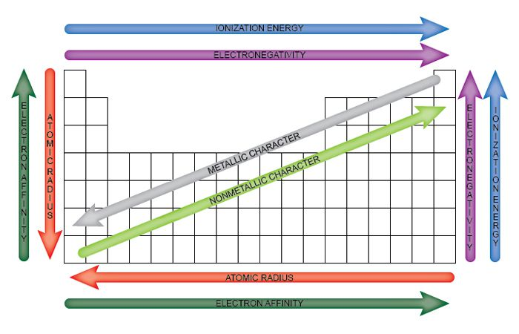

**Below you will find Specific Periodic Table Charts showing the values of: electron affinity, and atomic radius. Ionization energy and electronegativity are on their own pages.**

**Electron Affinity Chart Periodic Table**

