Uniform Accelerated Motion

1) Bumblebee jumps straight upwards with a velocity of 14.0 m/s. What is his displacement of after 1.80 s?

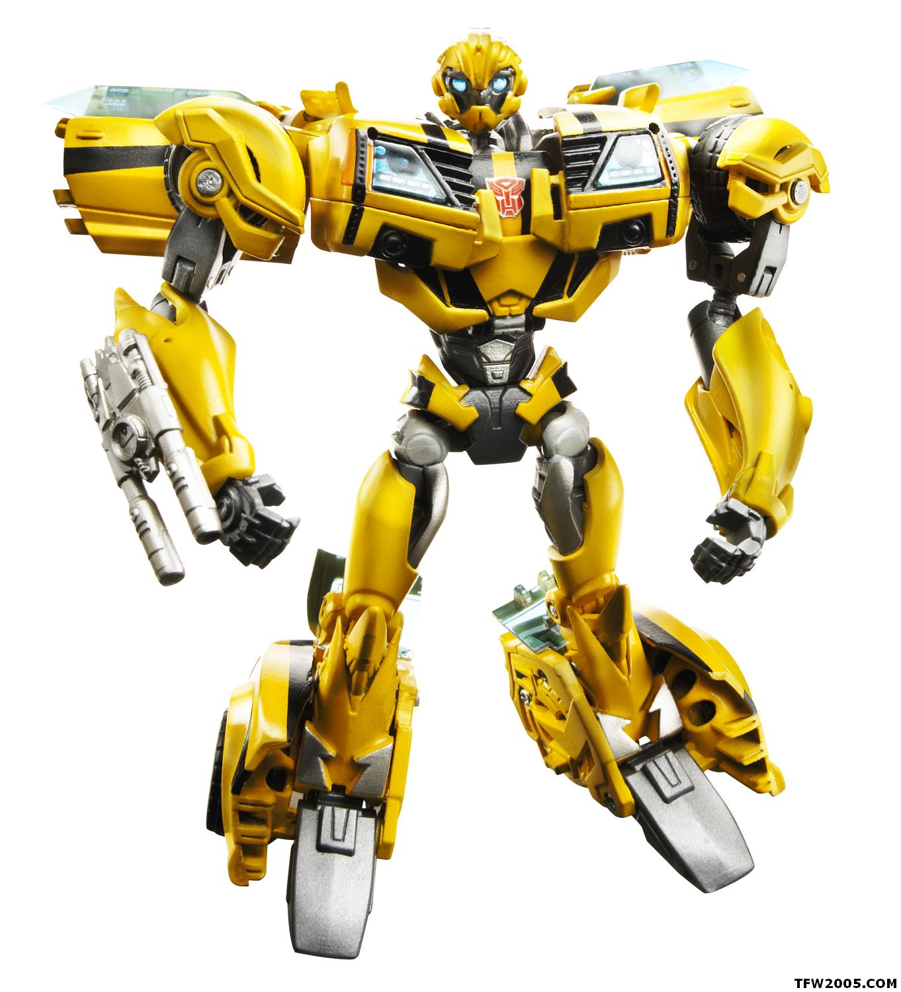

2) A surprisingly spherical decepticon is rolled up a constant slope with an initial velocity of 9.3 m/s. What is the acceleration of the decepticon if its displacement is 1.9 m up the slope after 2.7 s?

3) Optimus Prime coasts up a hill initially at 11.0 m/s. After 9.3 s he is rolling back down the slope at 7.3 m/s. What is his acceleration?

4) Sonic (you know, the Hedgehog) rolls up a slope at 9.4 m/s. After 3.0 s he is rolling back down at 7.4 m/s. How far up the hill is he at this time?



5) Luigi jumps straight upwards at 15.0 m/s. How high is he when he is travelling at:
a) 8.0 m/s upwards?
b) 8.0 m/s downwards?

6) Sick of his guff, Optimus decides to throw Megatron down off the top of a building at 5.0 m/s. Megatron hits the ground traveling at 32.0 m/s.

a. How long does it take to hit the ground?

b. How far does he fall?

7) Mario rolls a coin up a slope at 2.0 m/s. It travels 2.7 m, comes to a stop and rolls back down. What is the coin’s entire time of travel?


8) Princess Toadstool stands on the edge of a 30.0 m high cliff. She throws Bowser upwards at 20.0 m/s. If Bowser falls all the way to the bottom of the cliff, find:

- his velocity when he hits the ground. 

b. the time it takes to hit the ground.

