1st law of Thermodynamics Worksheet Name: ___________________________

Show your work.

- What is thermodynamics?

- What is internal energy?

- State the ﬁrst law of thermodynamics.

- What is an adiabatic process?

What is an isothermal process?

- Calculate ∆U for each of the following cases:

- Q = + 51 kJ, W = - 15 kJ
- Q = + 100. kJ, W = - 65 kJ
- Q = - 65 kJ, W = - 20 kJ
- In which of these cases does the system do work on the surroundings?

- Calculate ∆U for each of the following:

- Q = - 47 kJ, W = + 88 kJ
- Q = + 82 kJ, W = + 47 kJ
- Q = + 47 kJ, W = 0
- In which of these cases do the surroundings do work on the system?

- A system releases 125 kJ of heat while 104 kJ of work is done on the system. Calculate
the change in internal energy (in kJ).

- A system undergoes a process consisting of the following two steps:
Step 1: The system absorbs 73 J of heat while 35 J of work is done on it.
Step 2: The system absorbs 35 J of heat while performing 72 J of work.
Calculate the change in internal energy for the overall process (in J).

We will now investigate two thermodynamic systems.

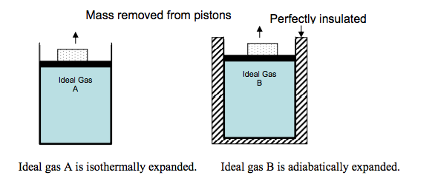
In the figure above, two cylinders are filled with the same ideal gas. A piston is fit so that no gas escapes; friction is negligible between the piston and the cylinder walls. The block is removed from each piston, the piston moves upward.

- In each case, does the gas do work or is work done on the gas? Explain your reasoning in a few sentences.

- Is there a larger transfer of thermal energy as heat between Gas A and the surrounding or between Gas B and the surroundings? Explain your reasoning in a few sentences. Draw an arrow on each figure indicating the direction of thermal energy flow.

- For the expansion of Gas A, how do the work and heat involved in this process affect the internal energy of the gas? Explain your reasoning in a few sentences.

- For the expansion of Gas B, how do the work and heat involved in this process affect the internal energy of the gas? Explain your reasoning in a few sentences.

We will now investigate a real-life example!
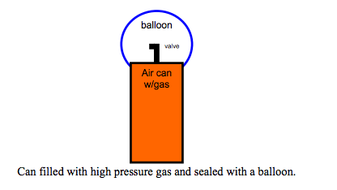
Use the figure above to make a prediction.

- What happens to the temperature of the gas inside the can as you allow the gas to expand into the balloon?

- Why does this temperature change occur? Explain the reasoning for your answer in a few sentences.

Note: Consider the system to be the balloon, the can, and the gas, everything outside of the can and balloon is considered the surroundings. There is NO loss of gas molecules during this expansion.

