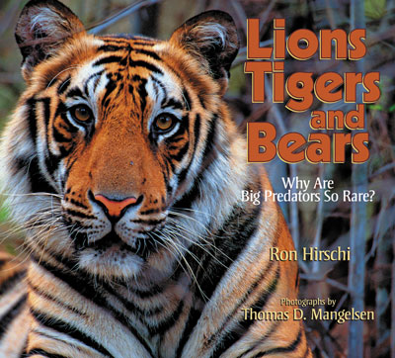
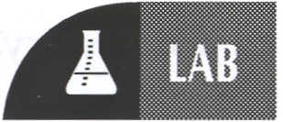

Lions, Tigers and Bears-Oh My
A Lab on Hair Identification of Different Species

Objective
You will collect and describe the hairs of several species of animals.

Background Information
As a trace evidence forensic scientist, you are often asked to identify hairs found at crime scenes. Sometimes you need to know whether or not a hair is human and if not, what type of animal it is from. You also may need to know if two different animals of the same species can be differentiated by their hair. In this lab, you are creating a set of reference hairs to help answer these questions.

Materials
Hair sample 1-from a dog
Hair sample 2-from a different dog
Hair sample 3-from a cat
Hair sample 4-from a different cat
Hair samples 5 through 9-from other species of animals – these are already prepared, or can be your own pet

Compound-light microscope
Slides
Cover slips
Small beaker of water
Dropper
Ruler

Procedure
1. Prepare a wet-mount slide of a hair from Sample 1 by:
a. placing a hair on the slide
b. adding a drop of water to the hair
c. covering the hair and water with a cover slip

2. Examine the hair under low, medium, and high power. Draw what you see on high power in the Data Table.
3. Determine the medullary index (MI) of the hair by measuring the diameter of the medulla and the diameter of the hair. Express these two numbers as a decimal fraction, the medullary–index, in the Data Table

4. Examine the root of the hair. Sketch that root in the Data Table. Examine the tip of the hair. Sketch that tip in the Data Table.

5. If possible, examine and describe the scales on the hair. Record this description in the Data Table.

6. Repeat steps 1 through 5 for hair samples 2 through 9.

Postlab Questions

- How are animal hairs like human hairs? How are they different? _______________________________

______________________________________________________________________________

______________________________________________________________________________

______________________________________________________________________________

______________________________________________________________________________

______________________________________________________________________________

- Compare and contrast the two different cat hairs: _____________________________________________

______________________________________________________________________________

______________________________________________________________________________

______________________________________________________________________________

______________________________________________________________________________

- What are some of the natural functions of hair? __________________________________________

________________________________________________________________________________________

________________________________________________________________________________________

________________________________________________________________________________________

________________________________________________________________________________________

________________________________________________________________________________________

- a. Describe the 3 stages of hair growth. B. Which stage of hair is most likely to be pulled out during a struggle?

________________________________________________________________________________________

________________________________________________________________________________________

________________________________________________________________________________________

________________________________________________________________________________________

________________________________________________________________________________________

________________________________________________________________________________________

- How can you tell by looking at hair through a microscope which stage the hair is in? _______________

________________________________________________________________________________________

________________________________________________________________________________________

________________________________________________________________________________________

________________________________________________________________________________________

- Define individual and class evidence. Then explain as specifically as possible, whether hair is class or individual evidence.

a. individual evidence: _________________________________________________________________

________________________________________________________________________________________

________________________________________________________________________________________

________________________________________________________________________________________

b. class evidence: _____________________________________________________________________

________________________________________________________________________________________

________________________________________________________________________________________

________________________________________________________________________________________

c. Is hair class or individual evidence? ____________________________________________________

________________________________________________________________________________________

________________________________________________________________________________________

________________________________________________________________________________________

________________________________________________________________________________________

________________________________________________________________________________________

- Of all the various characteristics of human and animal hair, name the one which you think has the most value and explain your choice.

________________________________________________________________________________________

________________________________________________________________________________________

________________________________________________________________________________________

__________________________________________________________________________________

DATA TABLE
Descriptions of hairs from several species of animals.
 | Hair | Species | Sketch of | Medullary | Sketch of hair and medullary pattern | Root sketch | Tip sketch | Scales
 | samples | of animal | entire hair | index | Sketch of hair and medullary pattern | shape |  | (sketch)
 | 1 | Dog-1
 | 2 | Dog-2
 | 3 | Cat-1
 | 4 | Cat-2
 | 5
 | 6
 | 7
 | 8

