Name___________________________
Period_______________________
Fish Video

- The earliest fish had a _______________________.
- There are nearly ________________ species of fish.
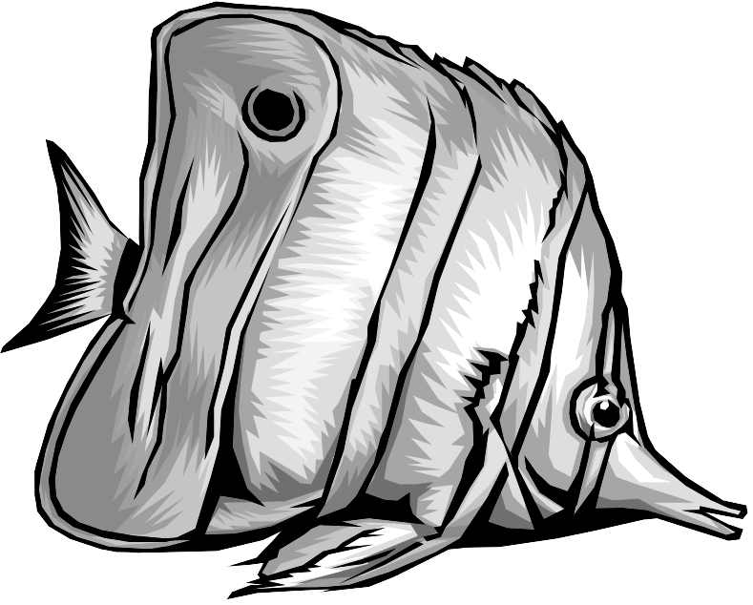
- Fish show these characteristics:
  - Bony ____________________
  - Swim ____________________
  - _____________
  - _______________
  - Lateral _____________
  - _________________
- Fish range in __________ and ________________.
- Fish live in ________________ or _______________________ and sometimes both.
- Name two ways fish catch other fish:
  - ______________________________
  - ______________________________
- Name two ways fish avoid being eaten:
  - ______________________________
  - ______________________________
8. Can fish make sounds? Yes No
9. The Gobi lives mutualistically with a __________________.
10. Most fish reproduce ___________________ by fertilizing eggs __________________ the body.

