DNA: The Secret of Life (Chapter 12) – 30 min Name ____________________

1. What is inside every living cell? _________________
2. What four chemical building blocks make up DNA? A, ____, G, ____
3. Rosaland Franklin took a famous picture using x-ray crystallography of DNA. How did thispicture helped Watson and Crick with their discovery?

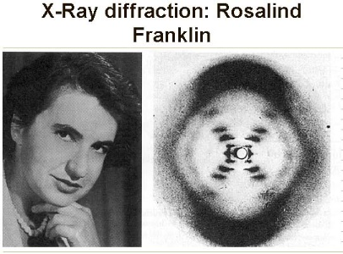

1. What was the discovery made by Francis Crick and James Watson in 1953?
2. In one strand of “A” pairs with ___________ and “G” pairs with _________.
3. ________________________ unwinds DNA so it can be copied or replicated.
4. A _____________ is a length of DNA code letters that make a protein.
5. Proteins are made of amino acids. There are _________ amino acids.
6. _________________ is made from one strand of DNA. RNA is different because it does not have “T,” instead it has “U.”
7. Where is protein built/assembled inside the cell? ________________
8. Sickle cell is caused by a change or mutation in the DNA. How does someone get this disease?
9. The total number of human genes is 22,000 (at the time of the video they thought it was 30,000). Only about _____% codes for proteins.
10. How similar is a humans and mice genetically? ___________