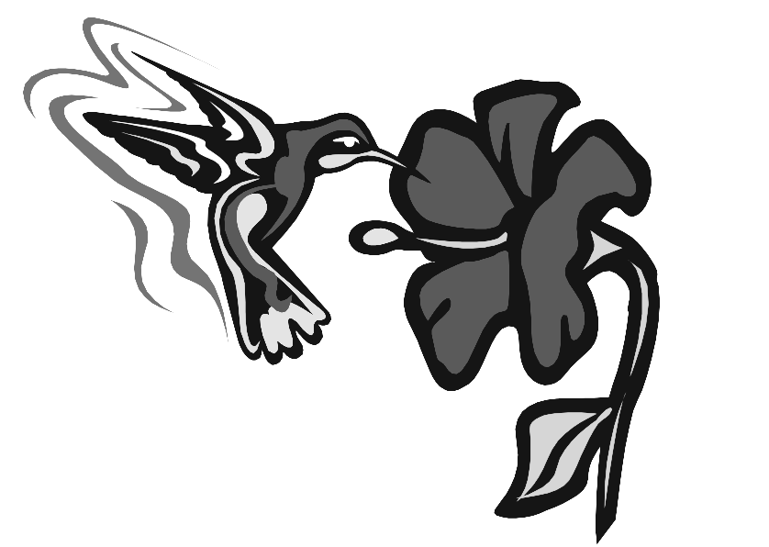
Name___________________________
Period_______________________
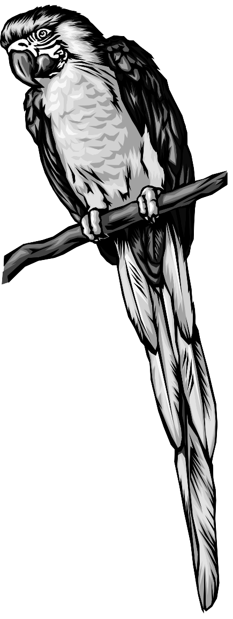
Bird Video

- The first bird lived _________ million years ago.
- There are over ____________ species of birds.
- Bird song is used for ________________.
- A bird’s bones are almost ________________.
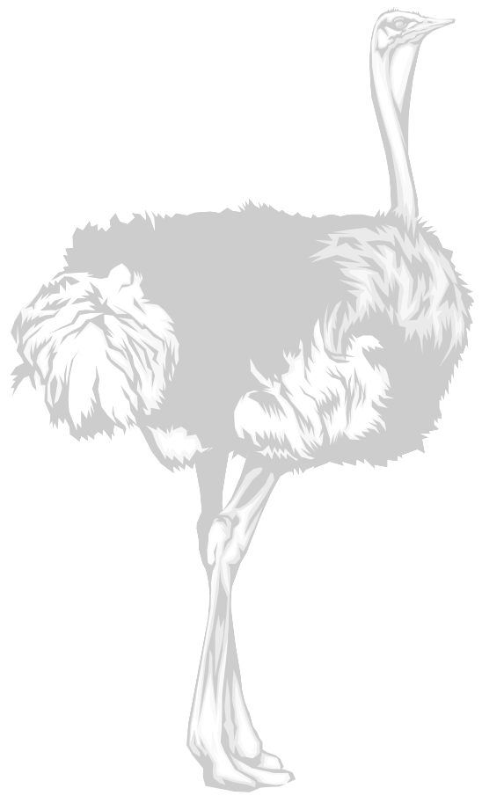
- Hummingbirds can beat their wings ________ times/sec.
- Birds have ___________ temperatures and __________ heartbeats.
- When a bird preens it is “______________________” up its feathers.
- The ostrich is the world’s _______________ and __________________ bird.
- Contrary to popular belief, the ______________ is one of the least intelligent of birds.
- The shape of a bird’s beak is determined by its ________________.
- Birds may use their ______________________ for courtship.
- Name two materials that nests can be made from.
  - __________________________
b. __________________________

