Printable Metric Conversion Chart and Table
Length  Area  Speed  Volume | Weight  Temperature  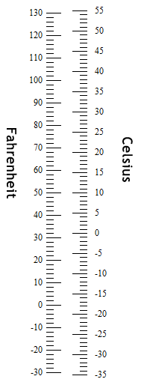
  1 centimeter (cm) | = | 10 millimeters (mm)
  1 inch | = | 2.54 centimeters (cm)
  1 foot | = | 0.3048 meters (m)
  1 foot | = | 12 inches
  1 yard | = | 3 feet
  1 meter (m) | = | 100 centimeters (cm)
  1 meter (m) | ≅ | 3.280839895 feet
  1 furlong | = | 660 feet
  1 kilometer (km) | = | 1000 meters (m)
  1 kilometer (km) | ≅ | 0.62137119 miles
  1 mile | = | 5280 ft
  1 mile | = | 1.609344 kilometers (km)
  1 nautical mile | = | 1.852 kilometers (km)
  1 square foot | = | 144 square inches
  1 square foot | = | 929.0304 square centimeters
  1 square yard | = | 9 square feet
  1 square meter | ≅ | 10.7639104 square feet
  1 acre | = | 43,560 square feet
  1 hectare | = | 10,000 square meters
  1 hectare | ≅ | 2.4710538 acres
  1 square kilometer | = | 100 hectares
  1 square mile | ≅ | 2.58998811 square kilometers
  1 square mile | = | 640 acres
  1 mile per hour (mph) | ≅ | 1.46666667 feet per second (fps)
  1 mile per hour (mph) | = | 1.609344 kilometers per hour
  1 knot | ≅ | 1.150779448 miles per hour
  1 foot per second | ≅ | 0.68181818 miles per hour (mph)
  1 kilometer per hour | ≅ | 0.62137119 miles per hour (mph)
  1 US tablespoon | = | 3 US teaspoons
  1 US fluid ounce | ≅ | 29.57353 milliliters (ml)
  1 US cup | = | 16 US tablespoons
  1 US cup | = | 8 US fluid ounces
  1 US pint | = | 2 US cups
  1 US pint | = | 16 US fluid ounces
  1 liter (l) | ≅ | 33.8140227 US fluid ounces
  1 liter (l) | = | 1000 milliliters (ml)
  1 US quart | = | 2 US pints
  1 US gallon | = | 4 US quarts
  1 US gallon | = | 3.78541178 liters
  1 milligram (mg) | = | 0.001 grams (g)
  1 gram (g) | = | 0.001 kilograms (kg)
  1 gram (g) | ≅ | 0.035273962 ounces
  1 ounce | = | 28.34952312 grams (g)
  1 ounce | = | 0.0625 pounds
  1 pound (lb) | = | 16 ounces
  1 pound (lb) | = | 0.45359237 kilograms (kg)
  1 kilogram (kg) | = | 1000 grams
  1 kilogram (kg) | ≅ | 35.273962 ounces
  1 kilogram (kg) | ≅ | 2.20462262 pounds (lb)
  1 stone | = | 14 pounds
  1 short ton | = | 2000 pounds
  1 metric ton | = | 1000 kilograms (kg)

