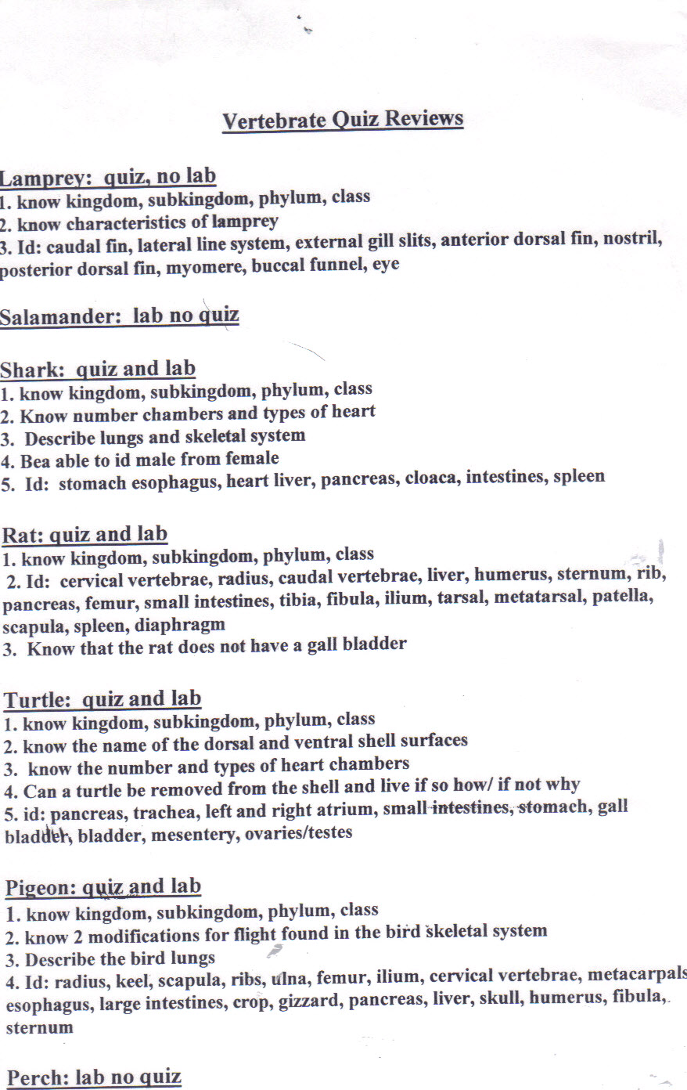

Frog: Quiz

- Know what class the frog belongs to
- Know the location of the kidneys on the frog
- Know what the large intestines and urinary bladder empty their waste into
- How many chambers does the frog heart have? Describe
- What are the two ways a frog breaths
- What is the shape of the frog stomach
- Be able to label: small intestines, liver, pancreas, spleen, esophagus, large intestines, cloaca, gall bladder, stomach

