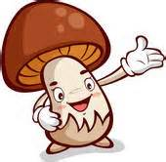Honors Biology Botany Lab Practical Review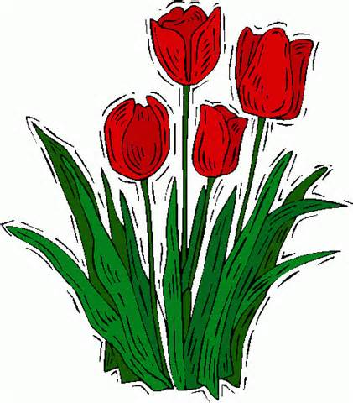

You may make a word bank on your own

46 questions

Plants:

Helpful pages in book:
roots: page 484, 485
leaves: page 483
stems: page 481

Dicot Root: be able to id as dicot, id xylem, phloem, and amyloplast

MonocotRoot: be able to id as monocot, Id root and pith

Monocot leaf: id as monocot, id vascular bundle, bulliform cells, guard cells, cuticle

Dicot leaf: id as dicot, id cuticle, palisade mesophyll, epidermis, stomata, guard cells, spongy mesophyll

Be able to id the following leaf environments: mesophytic, xerophytic, hydrophytic

Monocot stem: id as monocot stem, id vascular bundles

Dicot stem: id as dicot, id vascular bundles

Root: be able to id cortex, steel, epidermis and amyloplast

Fungus:

- Know what makes up a lichen
- Know what class penicillin belongs to
- Know what class mushrooms belong< be able to id cap, stalk, gills and basidiospores
- Bread mold: id class, hyphae, mycelium, sporangium
- Are yeast cells multicellular or unicellular?
- Know which class cup fungi belong

