A&P Endocrine Test Review

The best way to study for this test is to study my endocrine notes on this unit, they are attached at the end of this review

Matching set 1 (10Q)

Know description of the following glands:
Adenhohypophysis
Adrenal gland
Ovary
Pancreas ( islet of langerhans)
Neurohypophysis
Adrenal cortex
Hypothalamus
Parathyroid

True/False and Multiple Choice (22Q)

- Know what glands secrete ACTH, FSH, and ADH
- Know what element is essential for synthesis of thyroxine: its iodine
- Know what 2 hormones work against each other to regulate blood calcium: its calcitonin and parathoromone
- Know which hormone raises blood sugar
- Know that prolactin is regulated by releasing hormones and know its function
- Know function of parathyroid gland
- Know that Type I diabetes lacks insulin activity
- Know function of growth hormone
- Know function of FSH
- Know characteristics of hormones: includes duration of hormones varies, time required for onset of hormone effect varies and the persistence of a hormone in the blood is usually short lived
- Know function of ADH
- Know that the follicular cells of the thyroid produce thyroglobulin and the parafollicular cells produce thyrocalcitonin
- Know the location of thyroid and parathyroid glands
- Know examples of steroid based hormones: they include gonadal hormones such as testosterone, estrogen, progesterone, and aldosterone
- Know what type alpha cells produce in the pancreas
- Know that with age, the anterior pituitary gland, the adrenal gland and the gonads structurally change
- Know what ACTH does
- Know that amino acid derivatives can be hormones
- Know that gonadocorticoids are produced by the adrenal gland and is insignificant as compared to sex hormones released from the gonads during lat puberty
- Know that oxytocin causes uterine contractions and this is an example of positive feedback mechanisms
- Know that the parathyroid hormone is the most important regulator of calcium levels in the blood

Matching set 2 (11Q)

  - Know which gland releases the following hormones:

Cortisone oxytosin sebum
Calcitonin progesterone pathathormine
Growth hormone insulin epinephrine
Thymosin melatonin testosterone

Diagram: ( 9Q):

  - Be able to label:

Pineal body pituitary gland testis
Thyroid thymus pancreas
Parathyroid adrenal ovaires

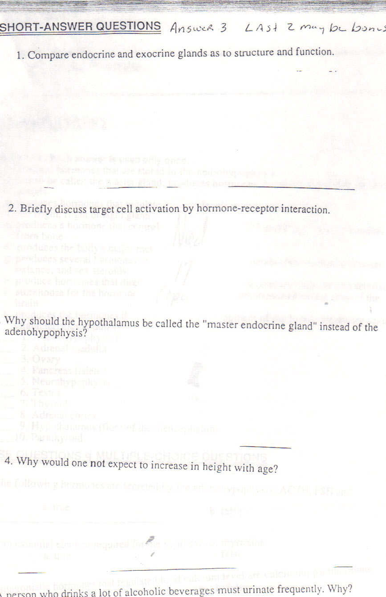

Endocrine System

- Hypophysis: (pituitary gland): 2 divisions:

- Adenohypophysis: (anterior pituitary gland):

  - FSH (follicle stimulating hormone): regulates hormonal activities
  - LH ( luteinizing hormone): regulates hormonal activities
  - ACTH ( adrenocortcotropic hormone): regulates endocrine activity of the adrenal gland ( cortex)
  - TSH ( thyrotropic hormone): regulates growth and activity of the thyroid gland
  - Growth hormone (STH) (Somatotropin): regulates body metabolism
  - LTH (Leuteotropic Hormone) (Prolactin): lactation of mammary glands
  - MSH (melanocyte stimulating hormone) : not significant in humans, possible darkens skin

- Neurohypophysis: ( posterior pituitary gland)

  - Oxytocin: uterine contractions
  - ADH (antidiuretic hormone): causes the kidney tubules to reabsorb water

- Thyroid Gland:

  - Thyroxine (T4): body metabolism ( follicular cells)
  - Calcitonin: decreases calcium levels (parafollicular cells)
  - T3: Triiodothyronine: It affects almost every physiological process in the body, including growth and development, metabolism, body temperature, and heart rate.

- Parathyroid gland:
a. Parathormine: increases calcium in body

- Pineal body:
  - melatonin: controls the daily night-day cycle, thereby controlling circadian rhythms of several biological functions. including sleep patterns

- Thymus:
  - thymosin: which promotes the maturation of T lymphocytes

- Gonads:

  - estrogen: 2ndary sex characteristics in females
  - progesterone: menstrual cycle in females
  - testosterone: 2ndary sex characteristic in males

- Pancreas:

  - insulin: ( beta cells): decreases blood glucose
  - glucose: ( alpha cells): increase blood sugar

- Adrenal Gland:

    - adrenal medulla:

      - epinephrine: fight or flight
      - norepinephrine: fight or flight

    - Adrenal Cortex ( 3 layers)

      - zona glomerulosa: releases the hormone aldosterone ( mineralocorticoid) : regulates sodium ion reabsorption by kidneys
      - Zona fasiculata: releases cortisone ( glcocorticoid): increases blood glucose levels
      - Zona reticularis: controls sex hormones ( gonadocorticoids)

